**Submit the following for the draft:**

1. In a word/text document describe the theme for your game. What is the genre for the game that you will be using (outer space adventure, cave adventure, other)?

I will be using Forest Adventure.

1. In the text document describe what images you will be using. Will you be using your own that you create or will you be using ones you find from other sites?  You can place a few images in the word document as an example for me to see.

I will be using image from the web

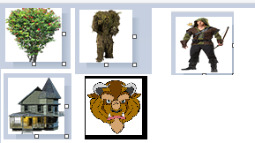

1. In the text document describe which aspects of ES6 you will be incorporating into the game.
2. In the text document describe how you may use jQuery with the game. You can also use Greensock animation tools if you'd like. The animation can be part of the interface or the start screen.
3. Finally include an HTML file and JS file. Create a simple start screen for the game. When the user presses a start button it should show the game map with an 8x8 grid. Obviously this does not have to be your final game, but at least a start screen (with game directions) and then a button click takes the user to the first draft of a game grid.
4. Place the text document, html, and any other necessary files into a zipped folder and submit here in this assignment area.